How to Winterize your exterior Faucets

- Determine how many exterior faucets/shutoffs you have.
- These should have ACS tags on them. Refer to plumbing page of report for
details.
- Most houses have one at the front of the house (or garage) and one at the rear.
- Some houses have a single shutoff for both faucets.

- Shut off water at each interior faucet.
- Open exterior faucets. If all interior faucets are off, very little water will drain
out at first.
- Slide the vacuum breaker “ring” up if your faucets have these (see left picture).
- Loosen/Open the small cap at the side of each interior faucet (see right picture) and replace after draining. Have a cup ready. Water may drain out here, or it may
drain out at the exterior faucet. (if a small rubber cap is
found after removing the metal cap, it too must be removed to drain the faucet).
- In some rare cases, the small cap is installed on the wrong side of the valve and
therefore cannot be used to drain the faucet since water coming out of this
opening will be under pressure. If water comes out at regular pressure,
re-install the cap and use the other methods mentioned to drain the faucet.

Note: I recommended draining all faucets before winter, including garage faucets and
any frost-free faucets as well.
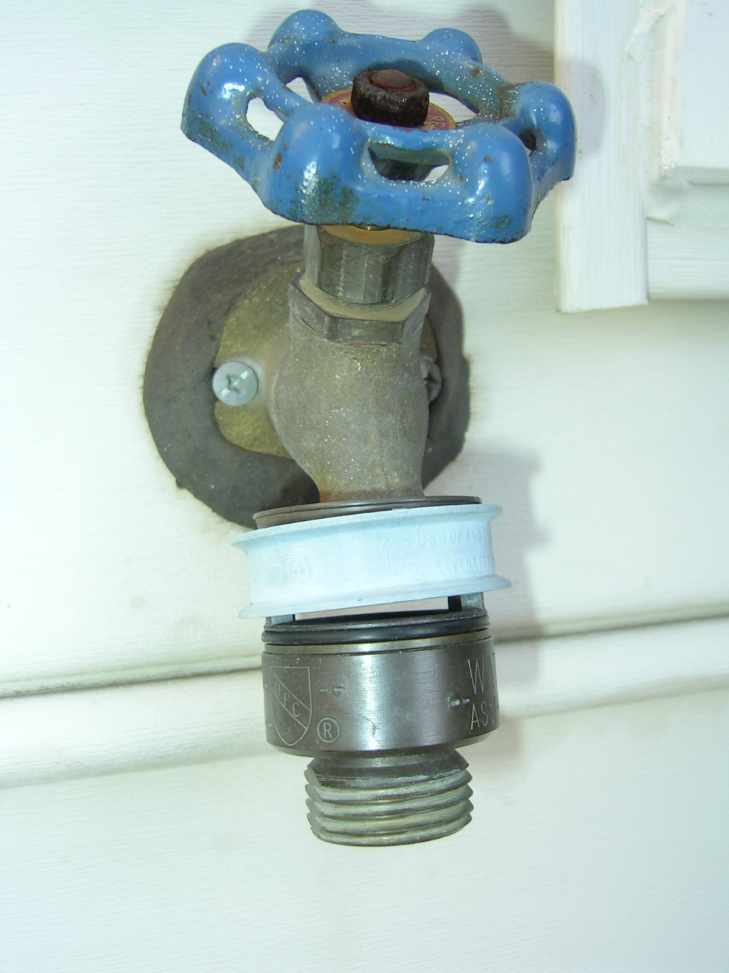

Vacuum breaker ring here is in “up” position Open small cap at left side of shut off valve to drain water left in pipe. This also releases pressure in the pipe. Water will not necessarily drain out of the cap.
